**USING RAPTOR – COMPUTE QUOTIENT AND REMAINDER**

**FLOWCHART**

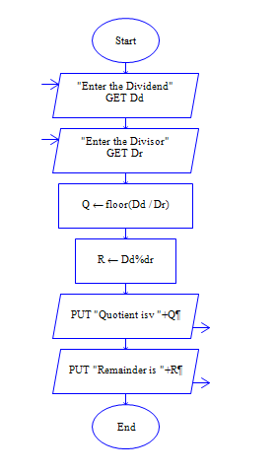

**OUTPUT**

DIVIDEND 9 AND DIVISOR 4

